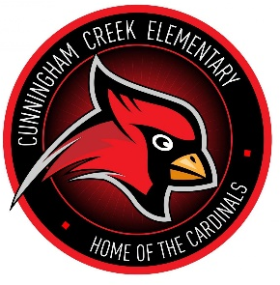
Cunningham Creek Elementary
A Learning Community of Caring Cardinals
1205 Roberts Road St. Johns, FL 32259 Phone: (904)547-7860 Fax: (904)547-7854

Katie O’Connell, Principal
Lydia Yeoman, Assistant Principal
David Barnes, Assistant Principal

Greetings Parents/Guardians,

This year, Cunningham Creek Elementary is embarking on an exciting journey! We are the first Certified Energy Bus School in St. Johns County. The Energy Bus is a book by best-selling author and speaker, Jon Gordon (https://jongordon.com/). In his book, Gordon outlines ten rules for life focused on positivity and teamwork. These rules have been adapted for a children’s audience in “The Energy Bus for Kids”. We will teach and model the “5 Rules for the Ride of My Life” for our students and host fun activities surrounding this initiative. What are the five rules?
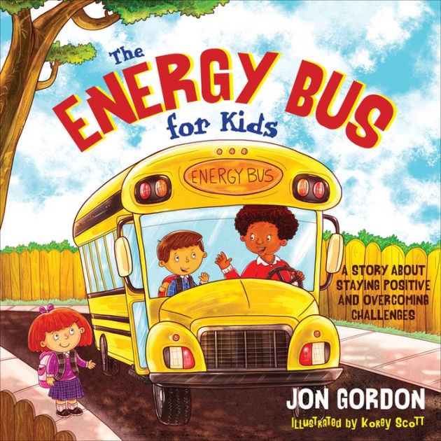
- Create a positive vision
- Fuel your ride with positive energy
- No bullies allowed
- Love your passengers
- Enjoy the ride

Each month, students will participate in an exciting Energy Week. During our Energy Weeks, we will recognize staff and students, participate in energy activities, and have a Spirit Day. Our staff and student recognitions include designating C.E.O.s (Chief Energy Officers) from each classroom who will be positivity champions with their peers. We want kids excited for a positive year, full of energy and school spirit!
Part of this initiative is to invite our students, parents, community members, and business partners onto our CCE Energy Bus. This is your ticket! We hope you will join us and enjoy the ride of your life. If you have any questions, please do not hesitate to reach out to me, Principal O’Connell. Thank you for being champions for the power of positivity at home.

Sincerely,

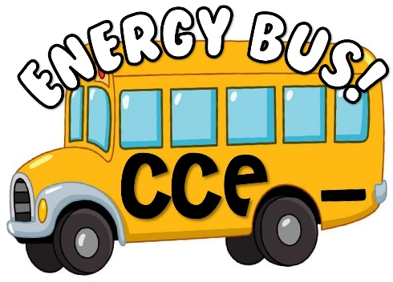
Katie O’Connell

