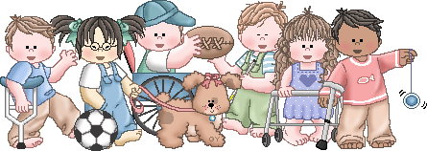

Pre-K Classroom Supplies

We recognize that each of our students has unique needs, so please feel free to send in what is appropriate for your child’s skill level.

CLASSROOM SUPPLIES: (Please DO NOT label)
1 – Pack Jumbo/Beginner/Learning Pencils
1 – Package of Washable Markers (Crayola brand)
6 – Glue Sticks
4 – Bottles of School Glue
2 – PLASTIC Folders WITH Prongs Color-RED
1 – Ream of Printer/Copy Paper
1 – Box Facial Tissue
1 – Roll Paper Towels
1 – Box Plastic Ziploc Sandwich Bags – 20+ count (boys only)
1 – Box Plastic Ziploc Gallon Bags – 20+ count (girls only)
1- Pack of cardstock white or colored paper.
4 – Packs of Baby Wipes – Unscented
3 – Containers of Clorox Wipes
1 – Bottle Hand Sanitizer
1 – Container of Playdoh (any color, Playdoh brand)
2 – Expo Dry Erase Markers (Expo brand)
PERSONAL SUPPLIES:
(Please LABEL ALL personal supplies
on outside with full first and last name)
Full size back Pack (no rolling or minis, please write first and last name on top/outside of pack)
Lunchbox (bring daily if packing lunch, please label on top/outside, please include drink with lunchbox)
Water Bottle (bring daily, please label)
20+ Diapers/Pull-ups (if needed, please label container)
2 Changes of Clothes (in a baggie, please label all clothes and baggie)
Blanket for Rest Time no bigger than a beach towel. (please label blanket, no pillows or lovies unless special circumstances)
Nap Mat- to keep at school

Wish List: Will be available at Meet-and-Greet.

Thank you so much for your support. We are excited about working with your child this year.
Sincerely, The CCE Pre-K Team

