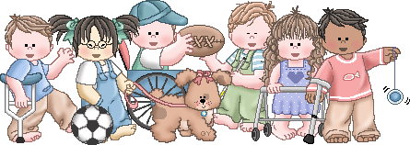

Pre-K Classroom Supplies

We recognize that each of our students has unique needs, so please feel free to send in what is appropriate for your child’s skill level. If there are special items that would be beneficial to your child, please feel free to send them in as well.

CLASSROOM SUPPLIES: (Please DO NOT label)
1 – Pack Jumbo/Beginner/Learning Pencils
1 – Package of Washable Markers (Crayola brand)
6 – Glue Sticks
4 – Bottles of School Glue
2 – PLASTIC Folders WITH Prongs Color-RED
1 – Ream of Printer/Copy Paper
1 – Box Facial Tissue
1 – Roll Paper Towels
1 – Box Plastic Ziploc Sandwich Bags – 20+ count (boys only)
1 – Box Plastic Ziploc Sandwich Bags – 20+ count (girls only)
4 – Packs of Baby Wipes – Unscented
3 – Containers of Clorox Wipes
1 – Bottle Hand Sanitizer
1 – Container of Playdoh (any color, Playdoh brand)
2 – Expo Dry Erase Markers (Expo brand)
PERSONAL SUPPLIES:
(Please LABEL ALL personal supplies
on outside with full first and last name)
Full size back Pack (no rolling or minis, please write first and last name on top/outside of pack)
Lunchbox (bring daily if packing lunch, please label on top/outside, please include drink with lunchbox)
Water Bottle (bring daily, please label)
20+ Diapers/Pull-ups (if needed, please label container)
Change of Clothes (in a baggie, please label all clothes and baggie)
Crib Sheet to Cover Rest Time Mat (please label)
Blanket for Rest Time (please label blanket, no pillows or lovies unless special circumstances)

Wish List: Will be available at Meet-and-Greet.

Thank you so much for your support. We are excited about working with your child this year.
Sincerely, The CCE Pre-K Team

