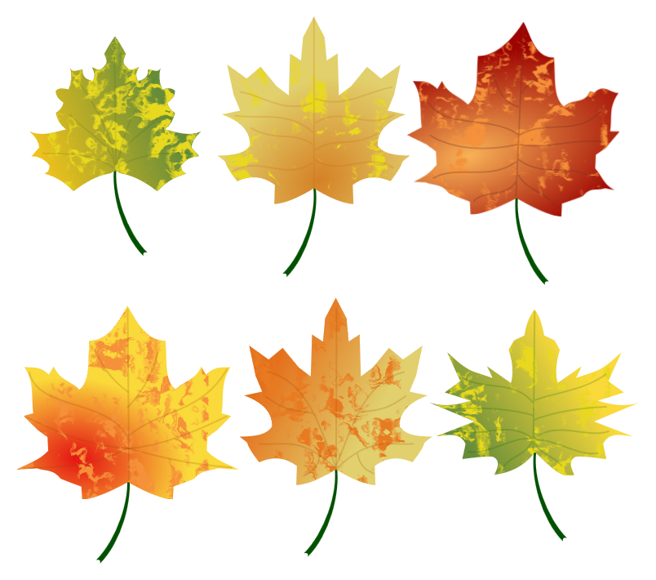 | Little Cardinals Nest  September 2026
Sun | Mon | Tue | Wed | Thu | Fri | Sat
 |  | 1 | 2  VPK VISITS MEDIA CENTER 11:30  VPK EARLY RELEASE  (IF ENROLLED FOR SCHOOL HOURS) | 3 | 4  Peeps - Wear Blue (Color of the Week)  VPK – Wear Red  (Color of the Week) | 5
6 | 7  HOLIDAY – NO SCHOOL | 8 | 9  VPK EARLY RELEASE  (IF ENROLLED FOR SCHOOL HOURS) | 10 | 11  Wear Your Favorite Football Team’s Jersey/Shirt | 12
13  GRANDPARENTS  BREAKFAST (CCE CAFE)   | 14 | 15 | 16  VPK EARLY RELEASE  (IF ENROLLED FOR SCHOOL HOURS) | 17 | 18  Wear LCN/CCE  Spirit Shirt | 19
20 | 21 | 22 | 23  VPK EARLY RELEASE  (IF ENROLLED FOR SCHOOL HOURS) | 24 | 25  TEACHER INSERVICE DAY/STUDENT HOLIDAY | 26
27 | 28 | 29 | 30  VPK EARLY RELEASE  (IF ENROLLED FOR SCHOOL HOURS)

